IC 140 (graphics for Design)
introduction to Auxiliary Views

These views are formed on planes other than the principal planes of projections (i.e., the frontal plane, horizontal (top) plane and the profile plane). Such planes are called auxiliary planes and they could be either Auxiliary Vertical Plane or Auxiliary Inclined Plane.
The AVP (Auxiliary Vertical Plane) is a plane that is perpendicular to the horizontal plane and inclined at an angle to the frontal plane (see e.g., Case I). A profile plane is special case of the AVP in which case the angle made by the vertical plane to the frontal plane is also 90⁰. The AIP (Auxiliary Inclined Plane) is a plane that is perpendicular to the frontal plane and inclined at an angle to the horizontal plane (see e.g., Case II). When the angle made by the auxiliary inclined plane to the horizontal plane is 90⁰, the auxiliary plane becomes profile plane.

Case I: Auxiliary projection of point P on an AVP is shown. The AVP is assumed inclined to the frontal plane at an angle of α and perpendicular to HP. Notice that the view formed on the AVP of the point P is at a height PP^{H} (shown in the figure by magenta color line). Also notice that the after the horizontal plane has been rotated by 90⁰ (as seen in the second figure), the AVP could be seen from the front as a line making an angle of α to the reference line FH. In the projections, therefore, the AVP is represented by a reference line HA drawn at the prescribed angle (in this case α) to the main reference line FH. The AVP is finally rotated by 90⁰ about the common intersecting line between horizontal and auxiliary planes as shown by the arrow. The auxiliary plane then lies vertical with HA inclined at the angle α to the FH line. The projection of the point P then lies on a line (projector) drawn from p^{H} that is perpendicular to reference line HA. The location of the view p^{A} along this line would be marked at a distance that is equal to the height of the point P from the HP. This height could be obtained from the front view as is clearly noticed in the first figure.

Case II: Auxiliary projection of point P on an AIP is shown in case II. The AIP is assumed inclined at an angle of β to the horizontal plane and perpendicular to the frontal plane. It may be noted that the distance of the view on the AIP (shown by p^{A}) is at a distance equal to p^{F}p from the frontal plane. This distance is actually the distance of the point from the common reference line FH in the top view (shown by orange color line in the illustration). Thus, when the HP is rotated by 90⁰ about FH to lie in vertical plane, the front view p^{F} and the top view p^{H} lie along a vertical line and the AIP can be seen from the front as a line FA inclined at β to the FH line. Now when the AIP is rotated by 90⁰ as shown by an arrow in the figure, the auxiliary view of the point P lies along a line (projector) drawn from the front view p^{F} and perpendicular to the reference line FA. The location of the auxiliary view p^{A} along this line (from the reference line FA) can be located at a distance p^{F}p, which can be obtained from the top view of the point.

Thus, while locating the auxiliary view on an AVP, project the top view across a reference line HA (drawn at an angle to the FH line) and locate from HA line the distance measured from the front view. Carefully observe the illustration of Case I.
Whereas, while locating the auxiliary view on an AIP, project the front view across a reference line FA (drawn at an angle to the FH line) and locate the distance measured from the top view from (&beyond) FA line. Carefully observe the illustration of Case II.

Case I: Projection of a Point on an AVP
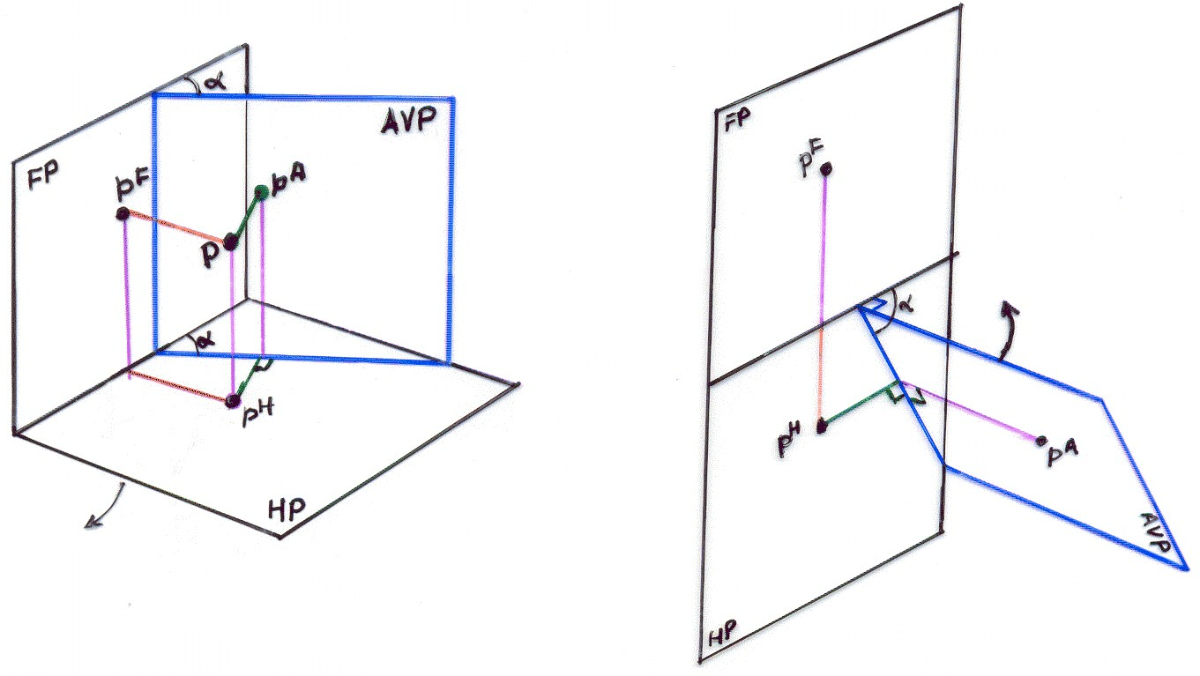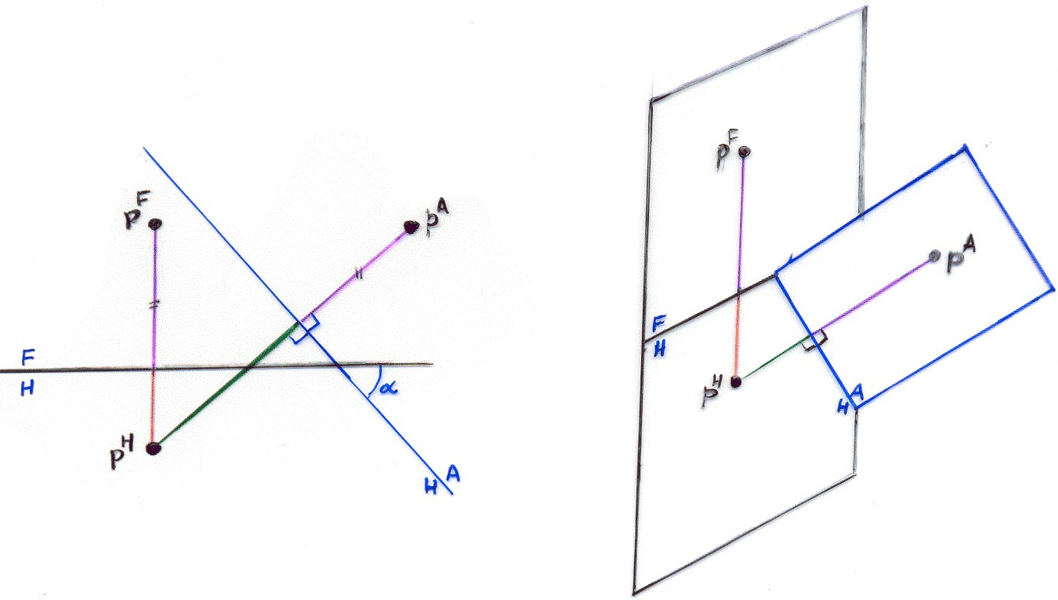

Case II: Projection of a Point on an AIP

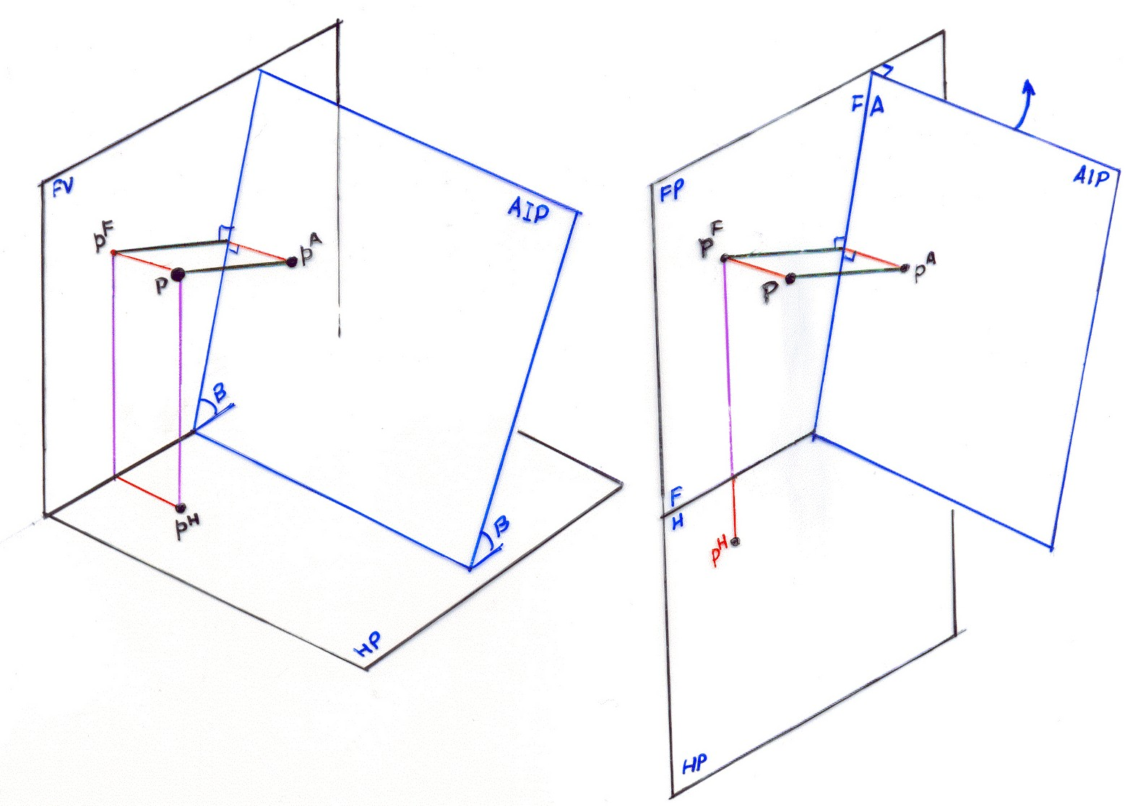
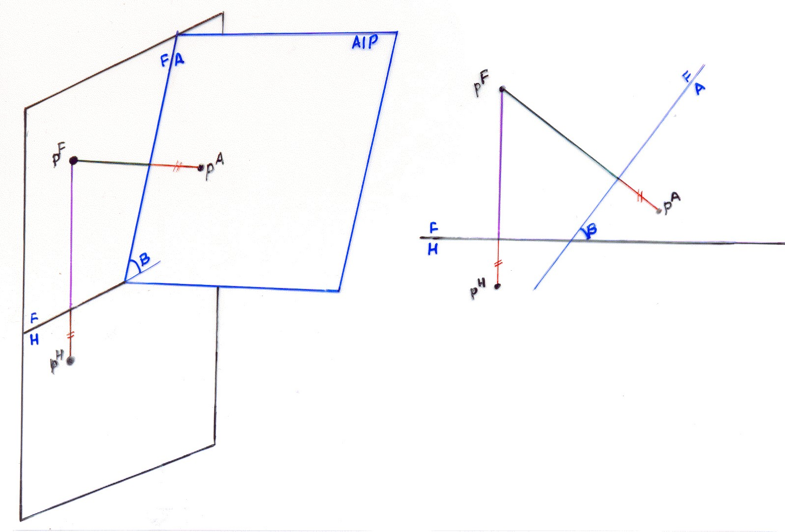

Case III: Projection of a Line on AVP and AIP
Notice the illustration given below for the auxiliary projection of line on AVP and AIP. For the case of projection of line on AVP (figure a), notice how the distance of auxiliary views of points A and B (aª & bª respectively) are equal to the height of these points from the HP, which can be obtained from the front view as shown by ≠ and × marks on the projectors. Notice how the auxiliary views of these points lie along projectors drawn from the top view a^{H}b^{H} across and perpendicular to the reference line HA (Figure c). This is because of the fact that the projectors from the points A and B are perpendicular to the plane of projection (in this case AVP). Hence the images of these projectors formed on the horizontal plane are also obviously perpendicular to the AVP represented by perpendicular lines from a^{H} and b^{H} to line MN (line of intersection of AVP and HP representing AH reference line). The images of the vertical projectors drawn from A & B (shown by ≠ and × marks) formed on the AVP are also perpendicular to the line MN. Thus, when the AVP is rotated by 90⁰about MN, the auxiliary views of end points of the line aª & bª (see figure c) lie on projectors from top view of the end points a^{H} and b^{H} and these projectors are drawn perpendicular to the line MN. The exact location of the views can be located (from the HA) along these projectors at distances measured from front view of the line (i.e., a^{F}b^{F}).
With similar logic, notice how for obtaining the projection of the line AB on an AIP (Figure b), the view is projected from the front view of the line and distances (shown by ≠ and × marks) measured from the top view of the line (Figure d).

Case III: Projection of a Line on AVP and AIP
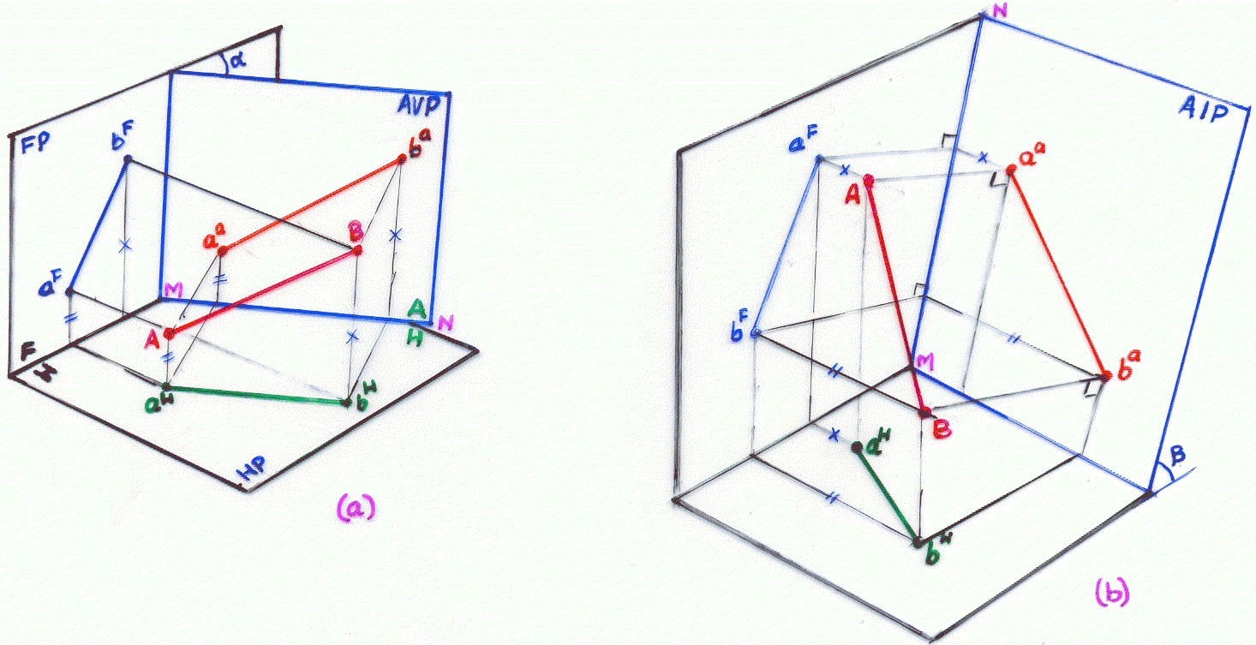
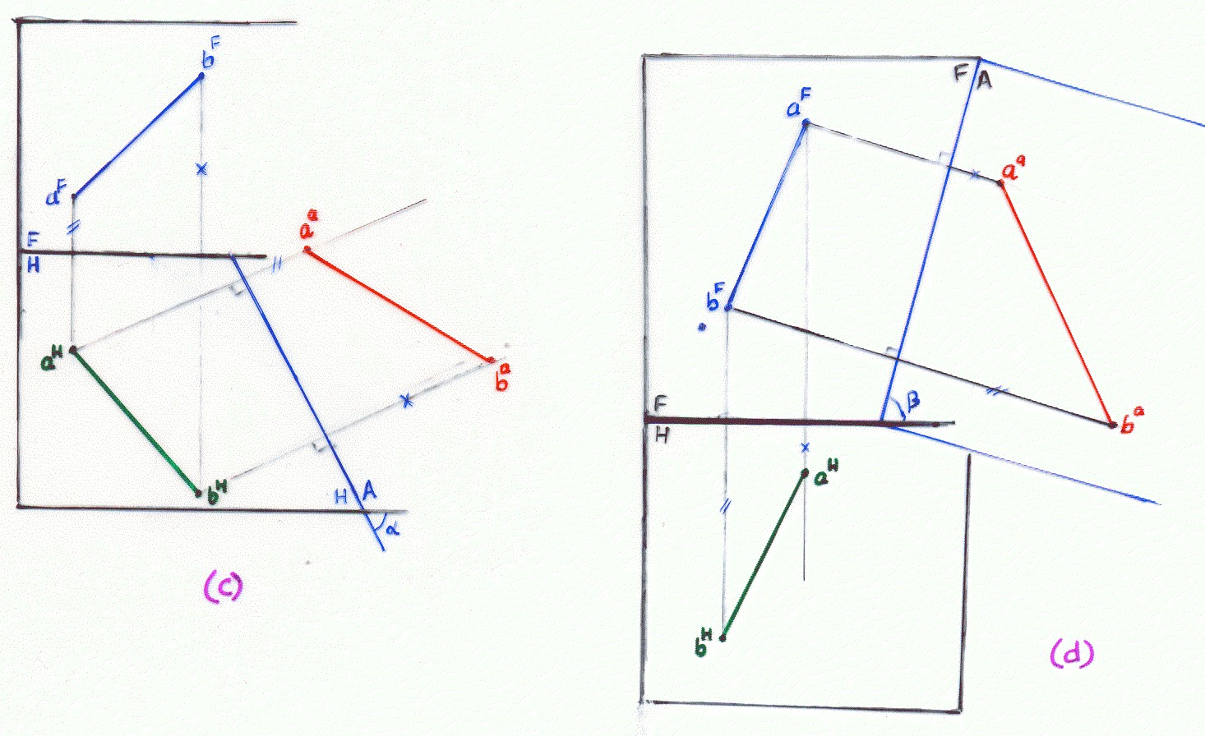

Case IV: Projection of a Point on a Secondary Auxiliary Plane

The projections on AIP and AVP help reveal features of the solid that lie on an inclined plane (to either of the principal planes). For example, a polygonal slot drilled on an inclined face of the parallelepiped would be seen in true shape and size when projection of the solid is drawn on a plane that is positioned parallel to the inclined face. However, to reveal features of an oblique face of a solid, projections must be drawn on an auxiliary projection plane that is oblique (inclined to both principal planes).

Consider projection of a point on an auxiliary plane that is inclined to both the principal planes of projections (FP & HP). Now such plane and projection thereon would be difficult to represent in a 2D representation. The projection on a secondary auxiliary plane is always drawn in two stages. A primary auxiliary view is first drawn on a primary auxiliary plane (either AVP or AIP) and then from this primary auxiliary view, another auxiliary view (secondary auxiliary view) is formed on an additional auxiliary plane (refer Case IV Figure). This additional auxiliary plane is called secondary auxiliary plane and is always perpendicular to the primary auxiliary plane but inclined to one of the principal planes of projection.

For example, in the illustration of Case IV, the primary auxiliary plane (PAP) is an AVP (inclined at 45⁰ to FP), whereas, the secondary auxiliary plane (SAP) is perpendicular to PAP and inclined at 60⁰ to HP (Figure IV-a). Thus, from the figure it is obvious that the secondary auxiliary plane is an auxiliary plane that is inclined to both the FP and HP. Thus 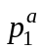 is primary auxiliary view formed on the AVP (inclined at 45⁰ to FP) and 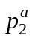 is secondary auxiliary view formed on secondary auxiliary plane that is inclined at 60⁰ to the HP. While drawing the views on a 2D representation, primary auxiliary view is first obtained following the procedure already explained in Case I. Note that is at a distance marked by ≠ from the HA₁ line and this distance is obtained from front view. Line HA₁ is oriented at 45⁰ to FH. Once is obtained, the secondary auxiliary view is obtained from , by first drawing the reference line A₁A₂ oriented at an angle of 60⁰ to the reference line HA₁.

It may be noted that when the HP is rotated by 90⁰, the PAP (and SAP with it) also rotates with HP (Figure IV-b). When HP lies in vertical plane after rotation as shown in Figure IV-b, the PAP (being originally perpendicular to HP) will then be seen in the front view as a line HA₁ inclined at 45⁰ to reference line FH. With HP positioned vertical, the PAP is now rotated by 90⁰ about MN so that it finally lies flat in vertical plane (Figure IV-c). It should be again noted that when the PAP is rotated by 90⁰ about HA₁, the SAP also rotates with it and when PAP is lying in a vertical plane, SAP becomes a plane perpendicular to the vertical (line of intersection RS) and inclined to HA₁ at 60⁰ and would be seen in the front view as a line A₁A₂ as shown in the Figure IV-e. Finally the SAP (denoted in the Figure IV-c as RSTV) is rotated about RS to lie flat in vertical plane (Figure IV-d). As all the projection planes (HP, FP, PAP and SAP) now lie vertical, the reference line for primary auxiliary view (HA₁) lies oriented at 45⁰ to the main reference line FH and the reference line for the secondary auxiliary view (A₁ A₂) lies oriented at 60⁰ to the HA₁.

To mark the position of the secondary auxiliary view, project the primary auxiliary view across A₁A₂ (Figure IV-e) and mark the distance p marked by a “°” (circled line) in Figure IV-a, along the projector drawn from primary auxiliary view. This distance is located along the projector from the line A₁A₂. This is also obvious from Figure IV-a, that the secondary auxiliary view of the point, lies in the plane RSTV at distance P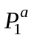from the line RS (which is actually the reference line A₁A₂). Note that the distance P (Figure IV-a) is the same as the distance of HA₁ from p^{T} in Figure IV-e (circled distance).

Case IV: Projection of a Point on a Secondary Auxiliary Plane
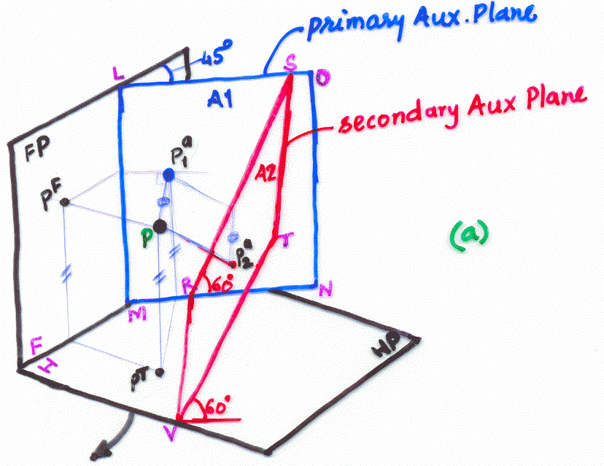

Figure IV-a
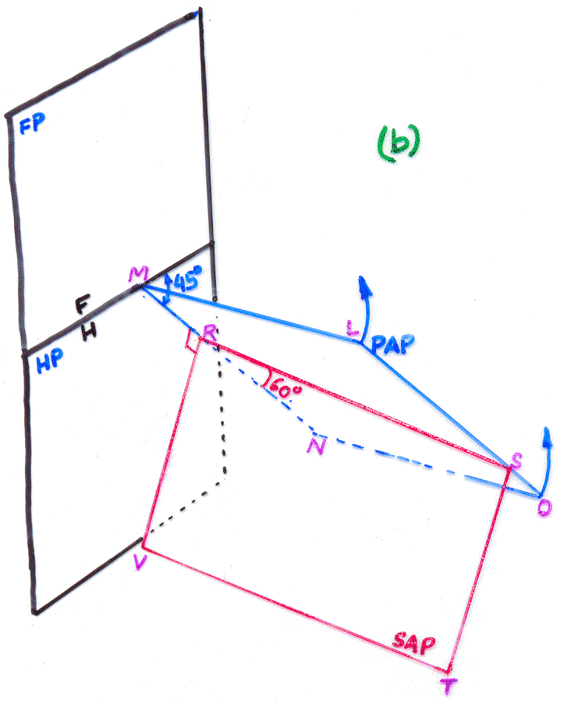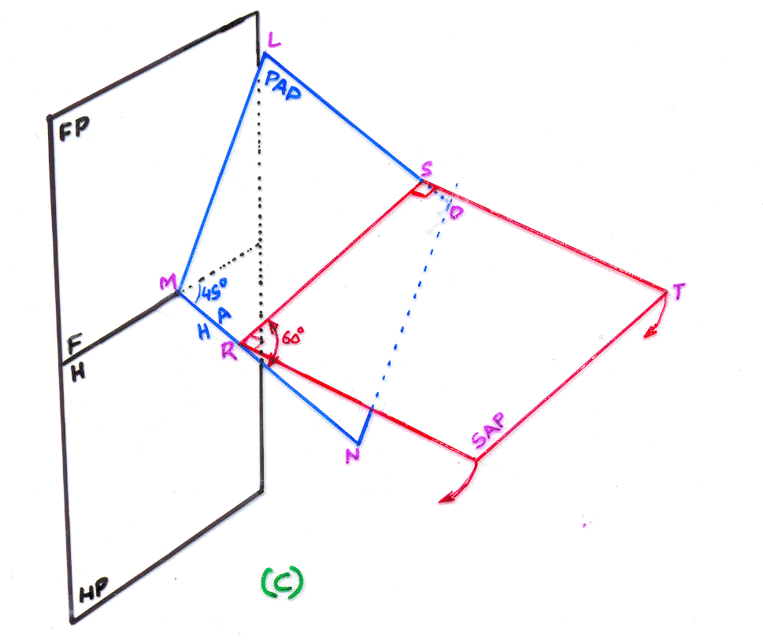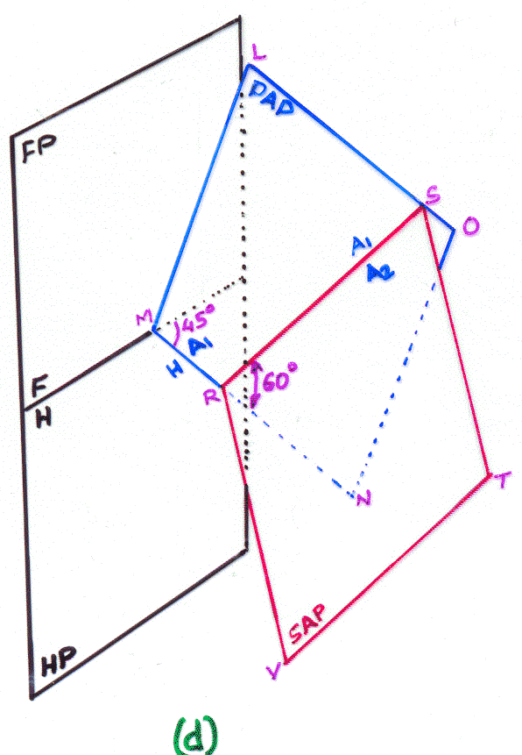

Figure IV-b

Figure IV-c

Figure IV-d

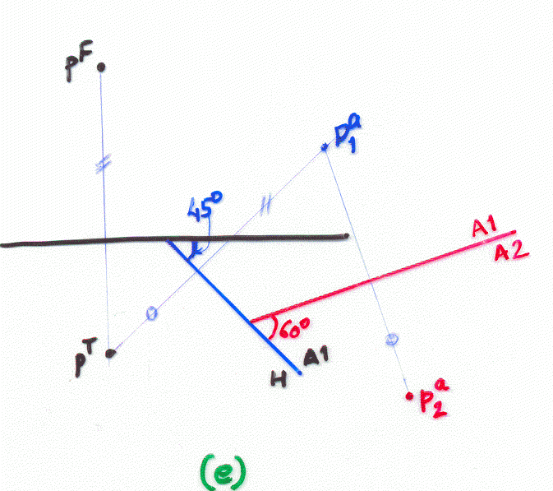

Figure IV-e

CASE V: Secondary Auxiliary View of a Line
The case presents secondary auxiliary view of a horizontal inclined line. In this case the SAP is considered perpendicular to both HP and PAP.
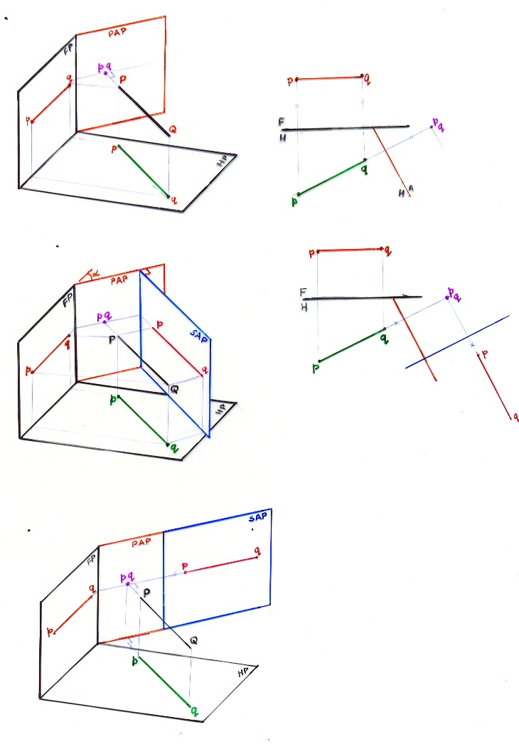
CASE VI: Auxiliary Projections of a solid on AIP

Figure VI-a

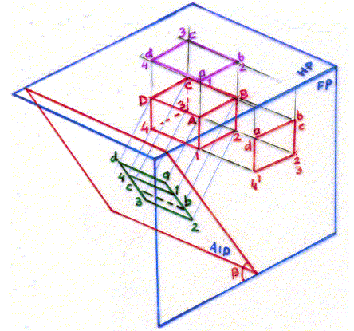

Figure VI-b
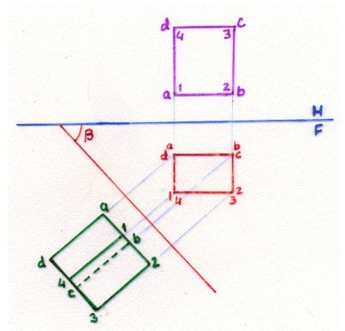
Figure VI-a shows a solid in 3rd angle method of projection with top and front view formed on HP and FP. An AIP makes an angle of β with HP. The primary auxiliary view is formed on AIP as shown. The projectors from all edges and corners of the solid are perpendicular to the AIP and are parallel to each other. These projectors would obviously be seen as projectors in the front view of the object across the reference line FA₁ that makes angle β with FH and is the line of intersection of the AIP with the FP (refer Figure VI-b). The view for the 2D representation would be obtained after rotating the AIP about the line of intersection FA₁. The projections are therefore taken from the front view as shown and are perpendicular to the FA₁ line, because the observer looks at the object across the AIP with lines of sight perpendicular to AIP (Figure VI-a) and hence the projectors drawn from the front view in Figure VI-b across the FA₁ line would be perpendicular to this line as shown.

CASE VII: Auxiliary Projections of a solid on AVP

The projections of the solid on an AVP inclined at an angle α to the FP are shown in the Figure below. Notice from the projected view that the corner A1 is closer to the AVP and would be clearly observed in the auxiliary view whereas the edge C3 is lying behind the solid and is not directly visible to the observer and hence should be shown as hidden line in the auxiliary view formed on the AVP.

